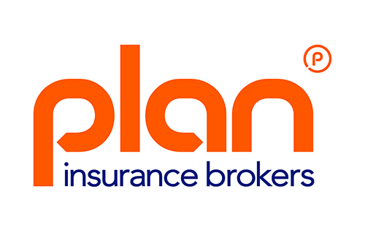
Plan Insurance Brokers ~ Press Release July 2015

Plan Insurance Brokers – check out our new look!
Over the last 25 years we’ve grown from being a small family business to being recognised as market leading commercial motor insurance brokers.

You might have known us as; Trade Plan, Taxi Plan, Van Plan, Chauffeur Plan, Commercial Plan etc. With so many trading names it was easy for you to become confused.

We felt it made sense to bring our sub-brands together and to update our image. From now on we’ll only contact you as Plan Insurance Brokers.

You’ll also notice a reworked logo, a modernised website and more. And there’s no need to worry…

You’ll still benefit from;
- Friendly, professional team members available when you need them

- Communications that are completely open and transparent

- Service and independent advice of a Gold standard (independently accredited by Feefo.)

- Customer experience enhanced not governed by technology

- Tailored insurance solutions that meet your needs as a professional road user

Our brand refresh is more than just a superficial make over. We’ve taken the opportunity to renew our commitment to you and focus our efforts to best meet your needs.
Our new “Keep your business motoring” is not just a clever play on words. It summarises our complete approach to the service and the products we provide. We realise just how vital your vehicles are to your businesses. Without them you cannot earn.
Keeping your business motoring communicates the added value of our expert advice and specialist knowledge. Our entire ethos is to minimise all the possible circumstances that might leave you without a vehicle.
Our approach turns risk into peace of mind.
www.planinsurance.co.uk

