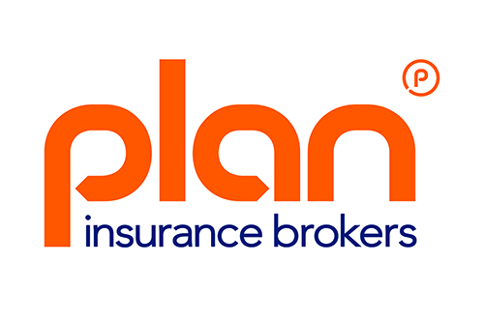
Plan Insurance Brokers ~ Press Release Jan 2016
Plan Insurance Brokers are honoured to be shortlisted for the Family Business of the Year Awards 2016 – which recognise and celebrate the contribution of family firms to the UK’s economy.
Hosted by Family Business United, a much valued magazine and resource centre, the awards are now in their fourth year. Concluding at a Gala Reception and London based awards ceremony on June 2, the winners will be crowned from 7 regions across the country.
As a family run, independent brokerage, Plan specialises in commercial motor insurance. Based in Surrey, the business was established 25 years ago by Peter Georgiades and his eldest son, Scott.
With Peter’s other two sons joining the business and helping it grow, whilst maintaining the principal of personal service and placing customers at the centre of what they do, Plan has built a trusted reputation for providing outstanding customer service and quality cover. And the company is steadily growing year on ear.
Quotes
“It’s probably the Greek in me but I’m incredibly proud of what Scott, Ryan and Grant have managed to achieve. They’ve grown the business whilst maintaining the principal of personal service and placing customers at centre of what we do.”
Peter Georgiades, Founder and Chair
“We eat, sleep and breathe the company together. But we weren’t confident about how much our own story mattered to clients. However, this [shortlisting] shows that people buy from people and the personal nature of the company really resonates.”
Grant Georgiades, Marketing Director and Youngest of the 3 brothers
"We are delighted to be able to pull together such a vibrant bunch of family businesses, some that have succeeded for numerous generations and continue to thrive, and others that are relatively young but have great values at the heart of what they do."
Paul Andrews, Founder and Managing Director of Family Business United
PLAN’S KEY STATS
GWP circa 17 million - 5 family members - 2 Generations
70 Staff based at 1 location in Surrey - established 25 years.
Voting is open online now for the prestigious People’s Choice Awards, determined solely by the Public Vote. All shortlisted businesses are entered into this as well as the Family Business of the Year 2016 title.
You can vote for Plan Insurance Brokers as your choice here up until the end of April.

What makes Plan stand out in the shortlist?
STRONG BRAND
The three brothers recognise that building a strong brand is not just about designing a logo. As a broker of commercial vehicle insurance, Plan’s clients depend on having their vehicles on the road - without them they cannot earn.
Therefore Plan’s entire company ethos is geared around helping to keep UK businesses motoring by minimising the chances they might be rendered vehicle-less following an incident.
INVESTING IN TECHNOLOGY
As a family business Plan has benefited from the fresh ideas and enthusiasm as younger members of the family have joined – and often stands out from its competitors. Its dynamic management team sees value in digital services.
Their investment in bespoke IT systems has benefitted clients by streamlining processes and they are also actively engaged with social media.
THOUGHT LEADERS
Plan is establishing as a thought leader within the commercial motor industry providing expert opinion and advice in areas of regulation.
Plan has recently been asked to provide TfL with opinion on the implications of Uber Pooling for private hire driver’s liability cover. A leading private hire drivers’ union has also requested that they review existing regulations to suggest improvements that will improve public safety.
DIVERSIFYING
Cycling is something the family are incredible passionate about. They recognised a real need for a quality product that would cover fellow cycle enthusiasts’ high value bikes. Thus Yellow Jersey Cycle Insurance was launched 18 months ago.
Already this team is working with Team Wiggo (Bradley Wiggin’s race team) and Matrix Fitness (Laura Trott’s race team) and is continuing to go from strength to strength.
CHARITY SPONSORS
Last but certainly not least are the whole hearted efforts of the Plan Team in supporting numerous local, trade and national charities through fundraising and other activities.
Please click the following links for more information regarding Plan Insurance Brokers and Family Business United

